Welcome to Kenwood Gymnastics Center!

Ways to Register with KGC
Visit our website www.kenwoodgymnasticscenter.com to register for classes. Select the Registration tab and click on Create Account to access the Parent Portal. Fill in the basic contact and student information, read and agree to Kenwood’s policies and waiver. Now you’re ready to sign up for classes!
Once you’ve found a class that works for you, send in an enrollment request by simply clicking on the icon that says OPEN or WAITLIST. You can join as many classes or wait-lists as you would like. Requests will be reviewed and responded to by email within 1-2 business days. Your confirmation email will inform you of one of these four enrollment categories; active, wait-list, denied, or trial as well as an explanation of your status. Feel free to email info@kenwoodgym.com with any questions about enrollment status.
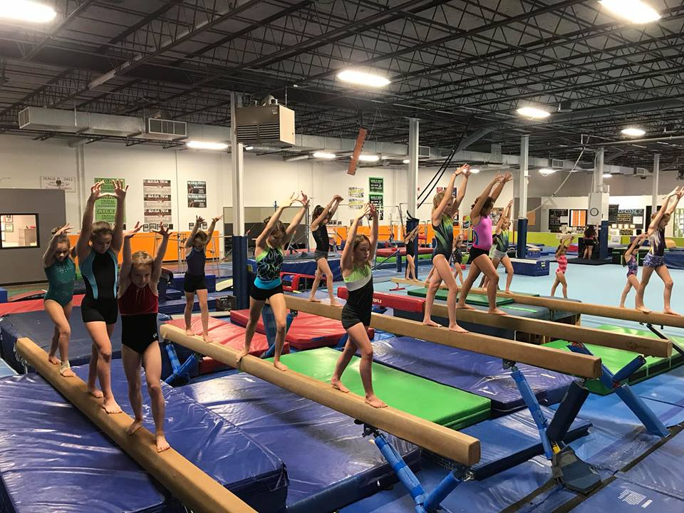
Continuous Enrollment
Once a student is enrolled, we will assume you plan to continue classes and will continuously bill you for these classes; we call this “rolling enrollment”. If you want to drop a class prior to the new month starting you need to notify Kenwood IN WRITING. You can notify us via our online platform or via email. Verbal drop notifications will not be honored. Drops are due BEFORE the 25th, for the upcoming month.

Transfer or Drop
If your student needs to change or drop a class, you can sign into your account to manage these tasks. This can also be done by calling or stopping at the front desk when you’re in the gym. Notification of a drop can be made anytime in advance but must be submitted before the 25th of the month. You can notify us in one of two ways: by selecting a Drop date in the Parent Portal or by email to info@kenwoodgym.com. If notification is not submitted (you simply stop coming) or is received after payment is due, you WILL BE BILLED for the next month. Without notification of a drop, you are still expected to pay for the secured spot you signed up for. There are often students on waitlists who could potentially be in those spots that are left unused.

Monthly Billing
Monthly tuition will vary depending on how many classes your gymnast will attend in a given month. Example: If your gymnast is in a Monday class and there are 4 Mondays in January, you will be charged for 4 classes. If there are then 3 Mondays in February, you will be charged for 3 classes in February.
Tuition will be prorated on the way into a month if enrolling mid-month but will not be prorated if you drop early.
KGC will prorate tuition for all gym closures. See our calendar to find these dates.

When to Pay
KGC uses a monthly tuition schedule for all programs. Tuition is due the 1st of the month OR day of processed enrollment. If you enroll mid-month, your card on file will be charged for the pro-rated amount due as soon as your request is approved. Tuition is posted on the 25th for the next month.

AutoPay
Autopay is REQUIRED for all families. You will be prompted to enter a credit card upon registering for any program. If you enroll mid-month, your card on file will be charged for the pro-rated amount due as soon as your request is approved. Autopay will run on the 1st of every month for any outstanding charges on your account. You are able to pay in alternative methods before the 1st of the month.

Make-ups
No make-ups will be allowed at this time due to our safety procedures. We are trying to keep groups the same and consistent to avoid cross contamination. In the event that you are not able to make a class, you will be allowed a make-up when we are allowed to do make-ups and/or open gyms start back up.

Refunds and Credits
KGC does not issue refunds or credits for missed classes, failure to notify gym of a dropped class after payment, auto-pay charges or a change of heart. If your student cannot continue classes due to injury or illness, please call the gym and that will be addressed in a case by case basis.
Advancing Levels
Our coaches are trained to monitor and document each student’s individual progress. Once your child has mastered the required skills to move up, our coaches will notify you about the new level change. Students are not required to change levels at any specific break, date or billing period. Coaches maintain a skills chart for each student, which you and your gymnast are welcome to inquire about and see at anytime. Just ask your coach!

